**Trailer Lights Tester**

**Release #2 technical requirements**

Revision: 5

Issue date: 12-09-2018

Author: Boris

|  |  |  |  |
| --- | --- | --- | --- |
| Version | Date | Author | Changes |
| 1 | 23-07-2018 | Boris | Initial |
| 2-4 | 27-07-2018 | Oleg | Review&Details |
| 5 | 12-09-2018 | Oleg | Align with HW design |

**Overview**

The device will be installed in front of trailer on the coupling device (near the trailer battery if present)

It is connected to trailer electrical vehicle connector from one side and trailer electrical harness from other side. Electric brakes signals pass by the device for safety reasons.

The device shall have two RF interfaces BT and Zigbee.

User can use BT connection to performs trailer lights diagnostics and system monitoring.

Zigbee is optional and used to collect data from wireless sensors installed into trailer.

The main device purpose is to give new user quick reference whether all is good with the trailer or not: check lights, brakes (hydraulic/electrical), doors/windows/roof/stairs position, monitor & log brake operation.

**TLT Release #2 should provide:**

* Hydraulic brakes pressure measurement
* Electric brakes voltage & current measurement for two brake lines (left and right)
* Accelerometer data handling to determine braking/impact event
* RTC for time & date features
* Brakes data storing
* ZigBee functionality to get windows/doors/roof position
* Wired sensor support for foot step
* Sleep mode with Zigbee Rx active and wakeup on RX
* BT connection to perform configuration, diagnostics, monitoring and log data download.
* Two buttons support (power up and diagnostics)
* 2 LEDs (GREEN + RED) for system status indication

**Structure scheme:**

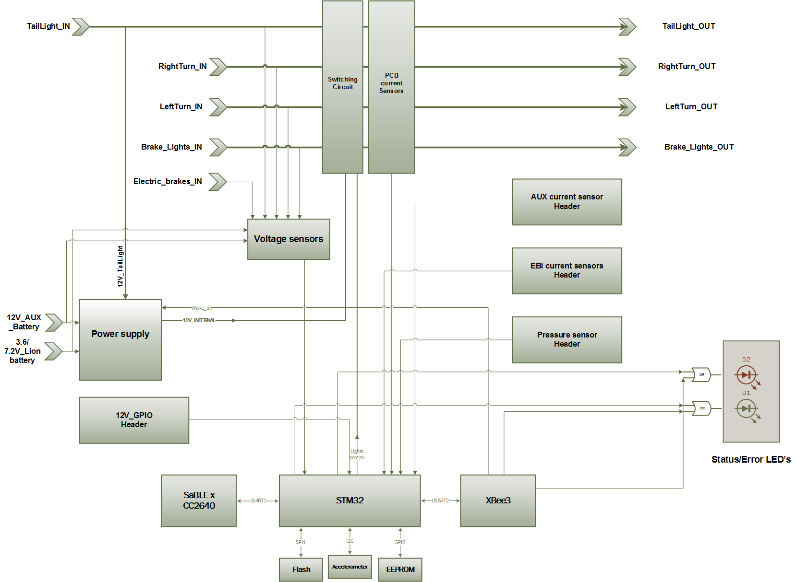



**Requirements description:**

**I Device operating modes**

TLT can operate with 3 power supply sources:

* Tail Light signal (TL)
* EXT12V: Trailer on-board 12V battery (~200Ah) charged from AUX
* own TLT nternal battery (1-2 cell battery 3,6-7,2 V battery) charging from TL

Internal battery and 12V are mutually exclusive and only one of them is supposed to be installed

Zigbee unit should only be populated when 12V Trailer battery is used as power supply. It is always listening for door/window sensor reports and wake up the TLT to record state.

When internal battery is used as power supply TLT shall switch to full off state if no BT connection established (within 5 minutes). The system shall wake up on power button press, TLT shall also wake up on when TL power or Aux power is applied, details on power state is presented in the table below:

|  |  |  |  |  |  |  |
| --- | --- | --- | --- | --- | --- | --- |
|  | | TL | EXT12V | | 3.7-7.2V from internal battery | |
|
|
|
|  |  | State | State | Wakeup Sources | State | Wakeup Sources |
|  | Bluetooth | ON | OFF | STM, wake up button, tail light | OFF | STM, wake up button, tail light |
|  |  |  |  |  |  |
|  | Xbee | ON | ON | N/A  (always on) | OFF/Not Installed | N/A |
|  |  |  |  |  |  |
|  | STM32 | ON | OFF | Wake up button,  LT+RT or Brake Light, E-breaks, Tail Light, Xbee (Data Available)  (accelerometer?) | OFF | Wake up button,  LT+RT or Brake Light, E-breaks, Tail Light |
|  |  |  |  |  | (accelerometer?) |

TLT can operate in three different modes:

- Trailer disconnected from vehicle (“on the shore”)

- Trailer connected to vehicle but not on the road (“take off”)

- On the road

1. On the shore (12 V battery option)

When trailer is not connected to the vehicle and 12V is installed the TLT shall indicate status of door/window/roof sensors (RED – open, GREEN – all closed)

TLT shall perform automatic lights test if diagnostics button is pressed. TLT will light up all channels consequently and check light current and report test result with status led (GREEN – ok, RED – issue).

User can also do visual inspection at the same time, for that case every light shall be turned on for at least 10 seconds.

1. On the shore (12 V or internal battery option)

User can wake up TLT with power up button, connect mobile phone and perform manual light test and check sensors status using mobile app.

TLT starts advertising for 5 minutes after wakeup.

BT bonding is optional. TLT shall reset bonding if user diagnostics button held for 10+ seconds

1. “Take-off”

Trailer is connected to a vehicle but is not on the road. Device gets its power from the battery or from any available power source.

If power taken from AUX input or Taillight is on, internal battery is charging (charge current limit – 500 mA).  
If user wants to perform “Take-off” diagnostics he/she has to wake up the device and connect to the TLTit with mobile phone.

User can test lights and electric brakes before trip using mobile application (“take off test”). User starts the test turning on TL/LT/RT and brake and get lights status/brake report from TLT

TLT supports lights calibration procedure to change factory defaults. Calibration procedure details are specified in requirements for mobile application.

TLT records new settings to NVM on application request

TLT blocks “shore test” (light controls) if Tail Light or AUX > 14V detected until diagnostics button is pressed again.

1. On-the-road

TLT shall wake up on brake signal (LT+RT, Brake Lights (EU) or brake signal for electric brakes) and analyze actual braking by accelerometer brake status (current value for EB and pressure value for Hydraulic brakes).

TLT shall monitor pressure sensor data for at least 5 seconds after braking event and get maximum value.

TLT shall record brake event value to the log (timestamp, acceleration, value)

TLT shall wake up on accelerometer event (impact) and record impact event.

TLT shall keep at least 1000 events.

If user enabled on-the-road monitor test in mobile application, TLT shall keep BT connection and report lights and brake warnings.

1. TLT shall provide real time brake status to the user on request.
2. TLT shall provide real time lights status to the user on request.
3. TLT shall provide brake logs to the user on mobile app request

**II Lights diagnostics**

Three basic lights channels are provided for diagnostics:

* Tail lights (also main power supply source for the TLT)
* Right turn
* Left turn

For European trailers additional channel should be provided:

* Brakes lights

Diagnostics is made by channel voltage & current measurement with comparison to reference values stored in the firmware.

Reference values can be changed with calibration procedure.   
Default values are factory preset to the standard trailer.

Calibration procedure can be run from mobile app.

Besides main lights source (vehicle actions like pedaling) TLT can generate own lights signals to make diagnostics. This mode is only available when trailer is detached from vehicle to avoid electrical signals concurrency. TLT shall generate light signals on user request from mobile app or by pressing diagnostics button. In case of diagnostics button pressed TLT shall turn all lights signals consequently.

TLT should have HW protection over lights control if AUX>14V is detected and software protection if TL/LT/RT + movement are detected. SW protection shall block lights control until diagnostics button is pressed.

Additional warning shall be provided to the user in mobile application.

**III Brakes diagnostics**

Two types of brakes are supported: hydraulics and electrical.

Hydraulics brakes diagnostics is made by pressure measurement with external sensor (should be comply with pressure for at least 2000psi (max is 1000psi for drum brakes, 1600psi for disk brakes see Carlisle-Hydrastar-Flier.pdf for reference)

TLT shall support 5V analogue sensor

TLT shall decode data from the sensor and compare with reference values taking in consideration data from accelerometer. Signal detection should be done only when braking event is taking place. This event is determined by active braking lights (BL, LT+RT), electric brakes signal and or accelerometer data if possible.

Accelerometer shall be calibrated at factory.

TLT should provide procedure to recalibrate accelerometer.

For the hydraulic brakes case, firmware shall measure pressure signal for at least 5 seconds after brake event detected . Maximum value is used for diagnostics & storing.

Electrical brakes diagnostics is made by voltage & current measurement. Typical current is 6A per brake, so TLT should measure current up to 12A and shall be able to measure current on left/right side brake separately.

Braking event detection and data storing is the same as for hydraulics brakes test.

Firmware and application should support both brakes types and, optionally, perform auto-detection.

Braking data should be available for app in the real-time.

**IV Additional channels diagnostics**

To be compatible with European trailers additional channel is required: brakes light. Diagnosis method is the same as for other lights.

Also, AUX channel diagnostics shall be provided – voltage & current measurement. Signals range: 0-15V, 0-30A.

**V ZigBee sensors support**

TLT provides additional help for drivers with notification about trailer state. ZigBee sensors data is collected and analyzed whether the trailer is ready to go.

Sensors can be installed to:

* doors;
* windows;
* roof;
* foot step (wired or wireless)
* awning.

TLT should implement ZigBee network coordinator role and provide joining procedure with mobile application assistance.

**VI Values storing**

Brakes data collected should be stored in the TLT’ flash memory. Amount of log entries should be not less than 1000.

Log entry format: <timestamp><brakes type> (<brakes voltage>|<pressure value>)<brakes current left><brakes current right><acceleration>.

Brakes current should be 0 for hydraulics brakes case.

RTC data should be used for timestamp. RTC is factory initialized but might be synchronized on each app connection or manually.

TLT shall provide power to RTC in case of main power loss.

In case of hit event will be detected with accelerometer specific log entry should occur.

**VII Mobile apps requirements**

Mobile app along with TLT shall provide:

* OTA
* real-time data from light, brake signals and sensors
* Lights signals generation (“Shore test”)
* Logs downloading & sharing
* BT pin-code protection (Phase 2)
* Lights and accelerometer calibration
* RTC initialization and sync (Phase 2)
* On-the-road monitoring and user notification.
* System testing “prepare to go” (“takeoff test”).

More details will follow in separate document for mobile apps.

**VIII Indication & running**

TLT can optionally provide standalone quick diagnostics procedure without app: perform all operations on button press and output result on green/red LED.

Wake up button functionality:

Device OFF -> wake up TLT (STM/BT) and TLT shall start advertising.

Device ON, No advertise -> start advertising

Device ON, BT connection -> Unlock lights control

Long press 10+ seconds -> Reset BT bonding if used

Diagnostics Button functionality:  
Short press - turn lights blinking one by one for 10 seconds (TL->LT->RT->BL)

Long press – full automatic test, turn on lights one by one for 3-5 seconds and measure current for EXT12V option) report state using LEDs

Green LED:

OFF – Power Off or Door/Windows sensors detected

FAST BLINK – advertise

SLOW BLINK – BT connection

ON – Door/Windows sensor is OK (any confusion with power state?)

Red LED

OFF – everything is OK (GREEN should be ON just in case RED LED is failed)  
BLINK - Lights failed  
ON – Door/Windows sensors detected

**IX Mechanical requirements**

Signal wires (up to 20 AWG) will be soldered to the PCB.

Own TLT power consumption should be no more than 50 mA.

TLT should operate within (5-60C) temperature range. (<5* C temperatures?) -20C to +60C

Power off switch might be installed for internal battery configuration

**X Comments/TBDs**

* EU/US version shall will have different BoM and FW (or configuration)

**Appendix A**

**Power source table**

|  |  |  |  |  |  |  |
| --- | --- | --- | --- | --- | --- | --- |
| Power source/Feature | Power Off mode | Internal Battery charge | Sleep/Power Off | Wake up*** | Light control | 12V battery charge |
| 12V Bat | Zigbee RX | n/a ** | 5 minutes if monitor off | Brake Light  Accelerometer | Yes | No |
| 7.2/3.7  Internal battery | Full Off | n/a | 5 minutes if no BT connection or monitor off,  Immediate after brake event logging | Brake Light  Accelerometer  Only STM | Yes | No |
| Tail Light | No | Yes | Never | Yes | No | No |
| AUX | No**** | Yes | Never | No, same as 12V bat | No* | Yes |

*AUX Voltage can’t be used for blocking light controls battery can have similar voltage, but current on AUX can be a sign of vehicle connection.

** No need for internal battery if 12V is installed

*** See full wakeup table

**** Need to detect AUX vs 12V battery