Eudora Setup
Before you start using Eudora, ensure that your environment meets the minimum system requirements, and configure Eudora following the provided instructions.
Minimum System Requirements
This specification defines the minimum system requirements for Eudora:
- An IBM PC-compatible computer running Windows 95.
- An instance of Eudora Lite application is installed and currently running.
- Internet access
- POP3 Email account.
NOTE: If you do not know the type of your Email account, contact your Internet Service Provider. POP3 is a client/server protocol in which Email is received and held by your mail software on the remote server. Presently, most mail software uses the POP3 protocol.
Configuring Eudora
To use Eudora for performing basic Email tasks, start Eudora and configure the program settings.

.
.
Eudora needs a few information to send and receive your mail messages.: Figure 1 illustrates Eudora User Interface and menu bar:
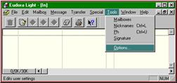
Figure 1. Eudora User Interface
To configure Eudora
- On the Eudora menu bar (see Figure 1), point to Tools, and then click Options.
This opens the Options dialog box similar to the following screen:
.
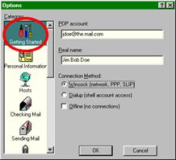
- Under Categories, select the Getting Started icon, and then specify your POP account information in the POP account and Real name text boxes, respectively.
TIP: Your POP Account is your username followed by the "@" symbol and the name of your Email server. For example, if your user name is "jdoe" and your server is ".mail.com", enter "jdoe@mail.com" in the POP Account space. )
- In the Real Name text box, enter your real name.
This name identifies you for your Email recipients.
- Under Connection Method, select the Winsock (Network, PPP, SLIP) option.
- Click OK to save your changes.
After completing this procedure, Eudora is ready to communicate with your Email server.

