CloudBerry Restore Wizard

Notes on Using the File Versioning Feature

Contents

1​ Introduction 3
​2​ Configuring the File Versioning Feature 4
​2.1​ Select Backup Mode 4
​2.2​ Configure the Retention Policy 5
​3​ How to Restore a Specific Version of Backed Up File 6
​3.1​ Start the Restore Wizard 7
​3.2​ Steps to Restore a Specific Version of a File 8

1​ Introduction
CloudBerry Backup automates the backup and restore processes to cloud storages. To make your recovery and restore operations simple and reliable, CloudBerry Backup provides the Back and Restore wizards with an intuitive and user-friendly interface.
To accelerate the backup process, every time a backup operation runs, CloudBerry Backup checks if the files have been modified since the last backup and uploads only modified files as new versions. This feature is called the files versioning.

This document helps you configure and use the file versioning feature to restore a certain version of a backed up file.

​2​ Configuring the File Versioning Feature
To configure a backup process, you should first create a backup plan using the Create Backup Plan wizard.

NOTE: This document overviews only basic steps related to configuring the files versioning feature. For detailed information on the Create Backup Plan wizard, refer to CloudBerry Backup Online Help.

​2.1​ Select Backup Mode
The file versioning feature is available only in Advanced mode of the backup plans. When creating a backup plan with the Create Backup Plan wizard, on the Select Backup Mode screen, select the Advanced Mode:
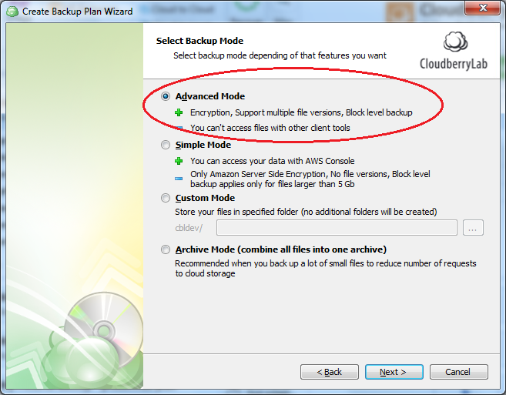

​2.2​ Configure the Retention Policy
The Retention policy settings determine criteria for storing files in cloud storages. For example, these settings specify a storage period or the number of the file versions to keep.
You can configure these settings on the Retention Policy page similar to the following screen:
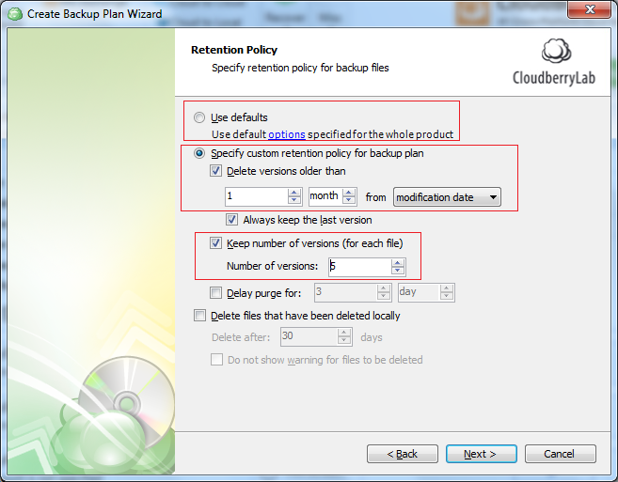

NOTE You can configure an individual retention policy for each Backup plan, or select the Use defaults option to apply a default retention policy specified for the whole CloudBerry Backup.

To set up default retention policy
- On the application toolbar, select Tools > Settings > Options.
- Navigate to the Retention Policy tab, and specify the default retention policy settings:
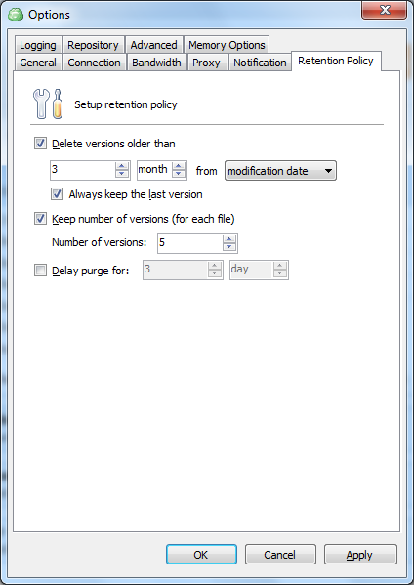
- Click Apply to save your changes.

​3​ How to Restore a Specific Version of Backed Up File
This section helps you restore a specific version of a backed up file using CloudBerry Restore wizard.
NOTE: This section overviews only basic steps related to selecting a file version to restore. For detailed information on the Restore wizard, refer to CloudBerry Backup Online Help.

​3.1​ Start the Restore Wizard

To launch the Restore wizard
- On the CloudBerry Backup User Interface, navigate to the Restore Plans tab, and click Restore.
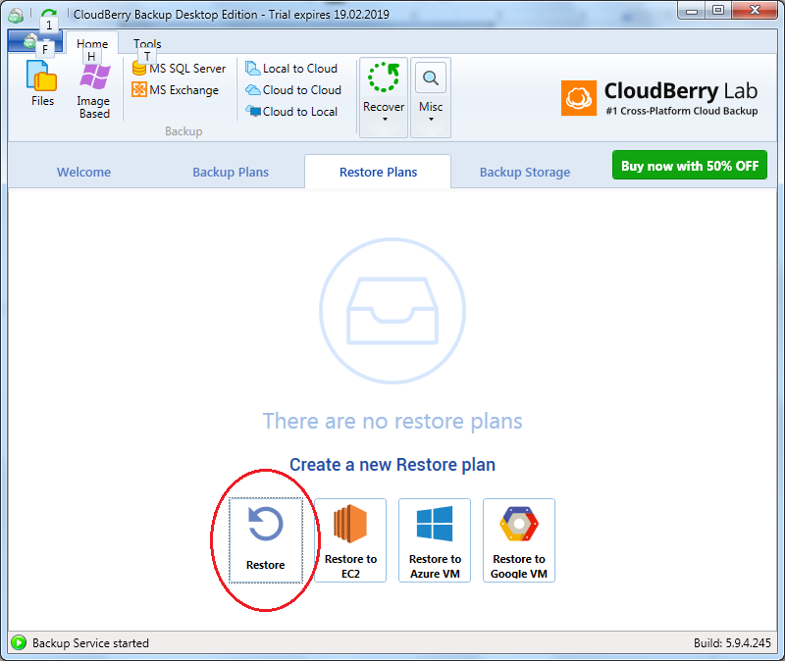

​3.2​ Steps to Restore a Specific Version of a File
After you launched the Restore wizard, follow on-screen instructions. Perform the following basic pages:
- On the Select Backup Storage screen, select a storage where your backup is stored.
- On the Restore Point screen, select the Manually option, and click Next to proceed with the wizard.
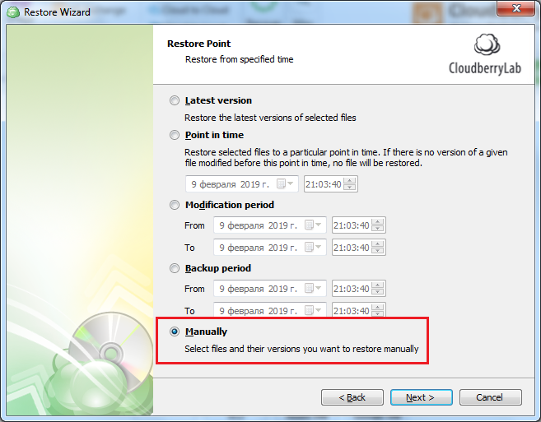
- On the Restore Source screen, select the file(s) version(s) to restore.
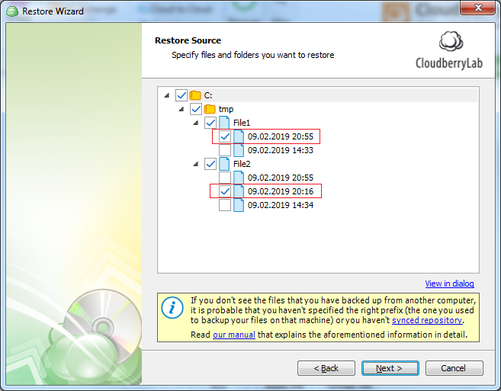
- On the Destination screen, specify a local folder where you want to restore selected files. You can save the files to their original location or select a new location for the restored files.
- Follow the wizard instructions, and on the Summary screen, review the specified restore settings. Cick Next to create the restore plan and start the restore process.
- Go to the local folder specified in Step 4 and check the restored versions of files.

